**Elasticsearch Lab 1**

**Qst_07:** Discover last 24 hours

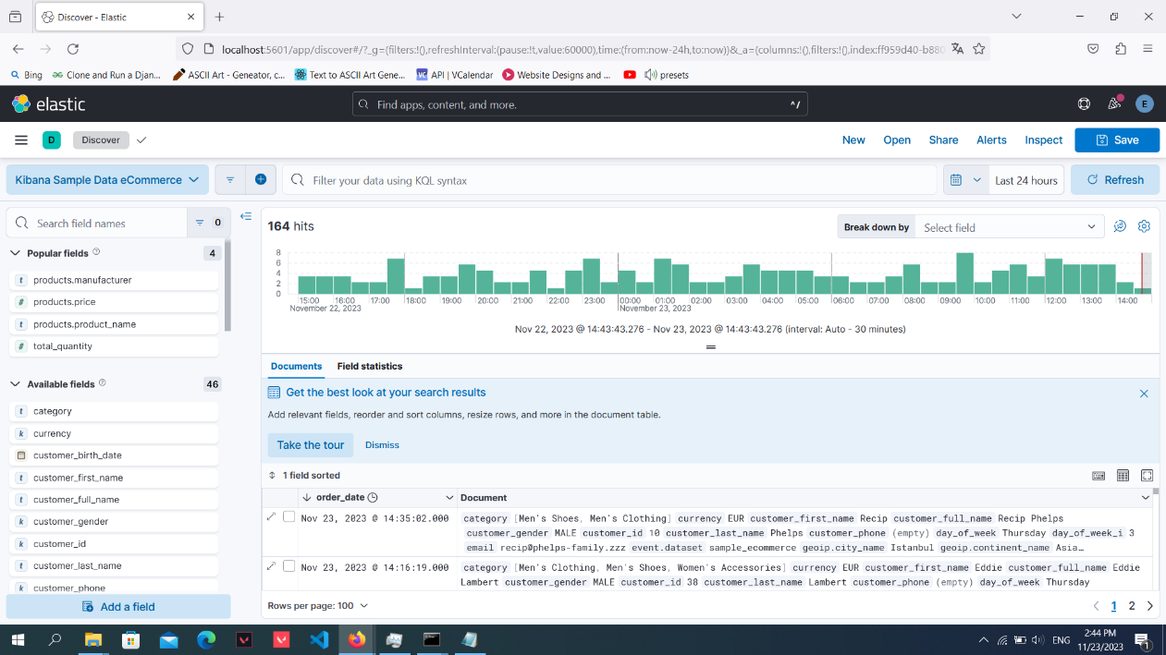

**Qst_08:** Dashboard

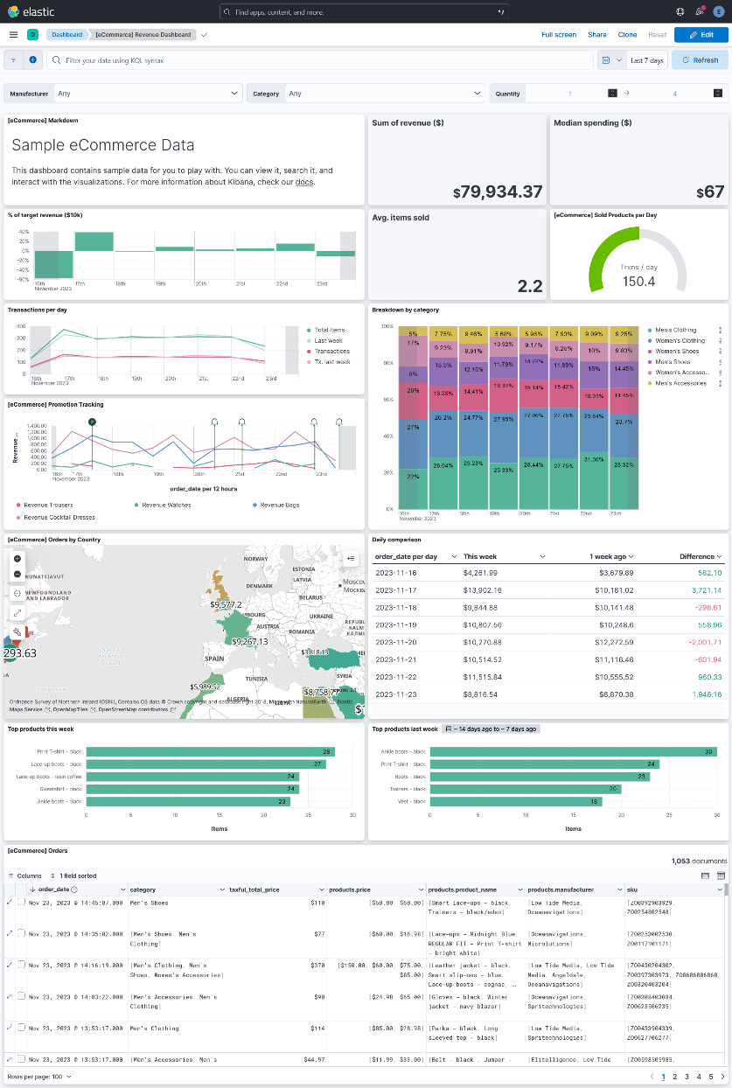

**Qst_09:**

Editing dashboard

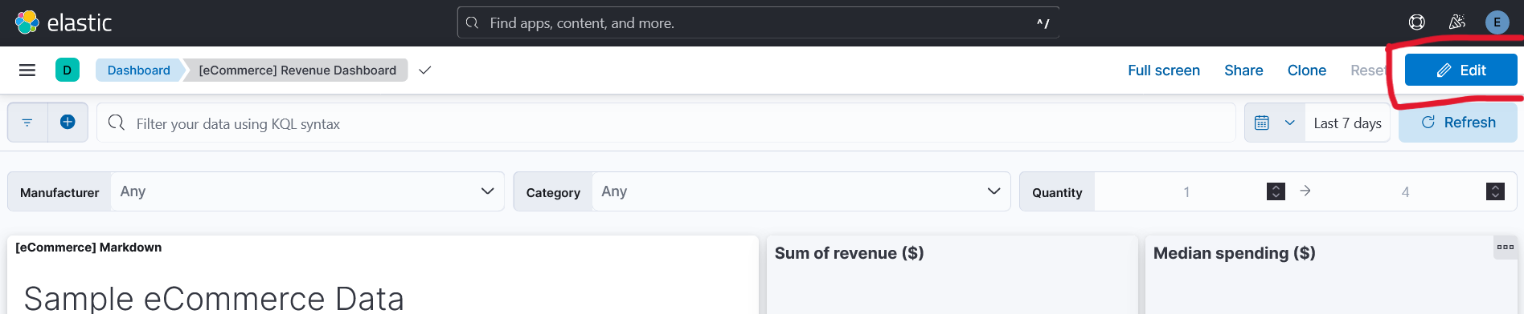

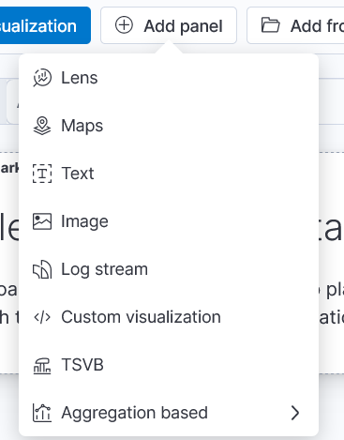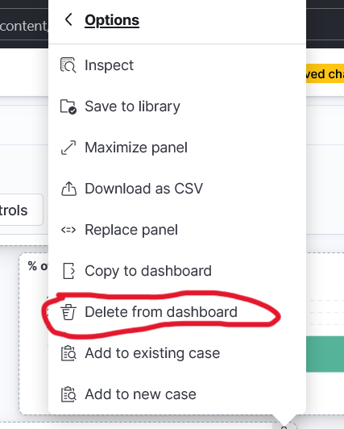

Add: Delete:

Result and saving

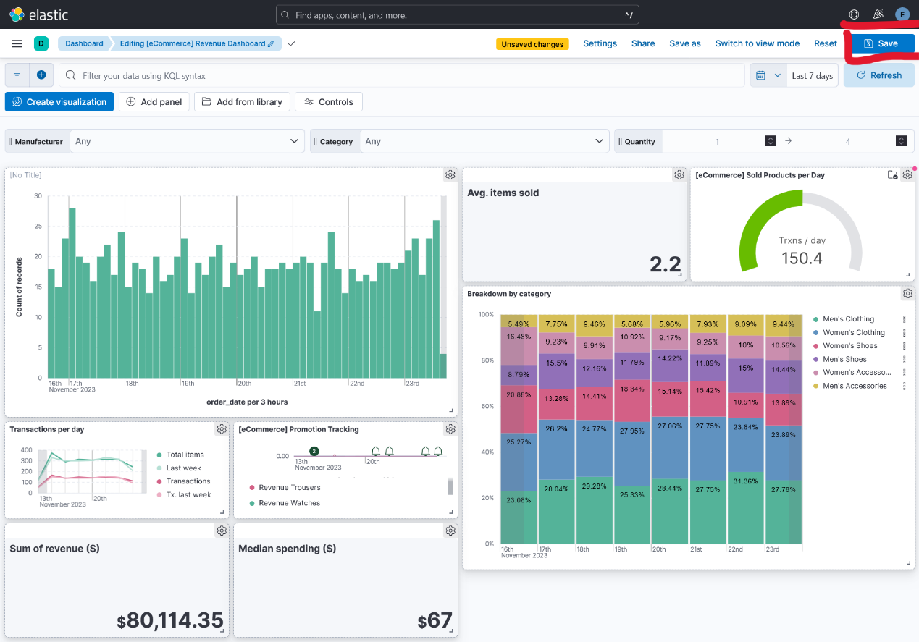

**Qst_10:**

1. GET / :

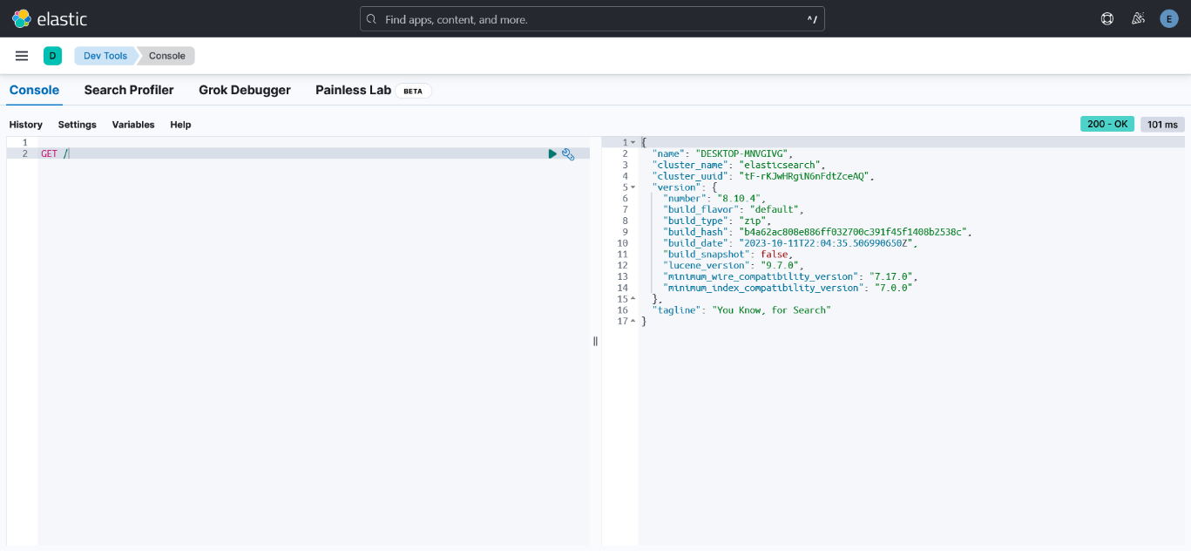

1. Ctrl+enter
2. the current indexes:

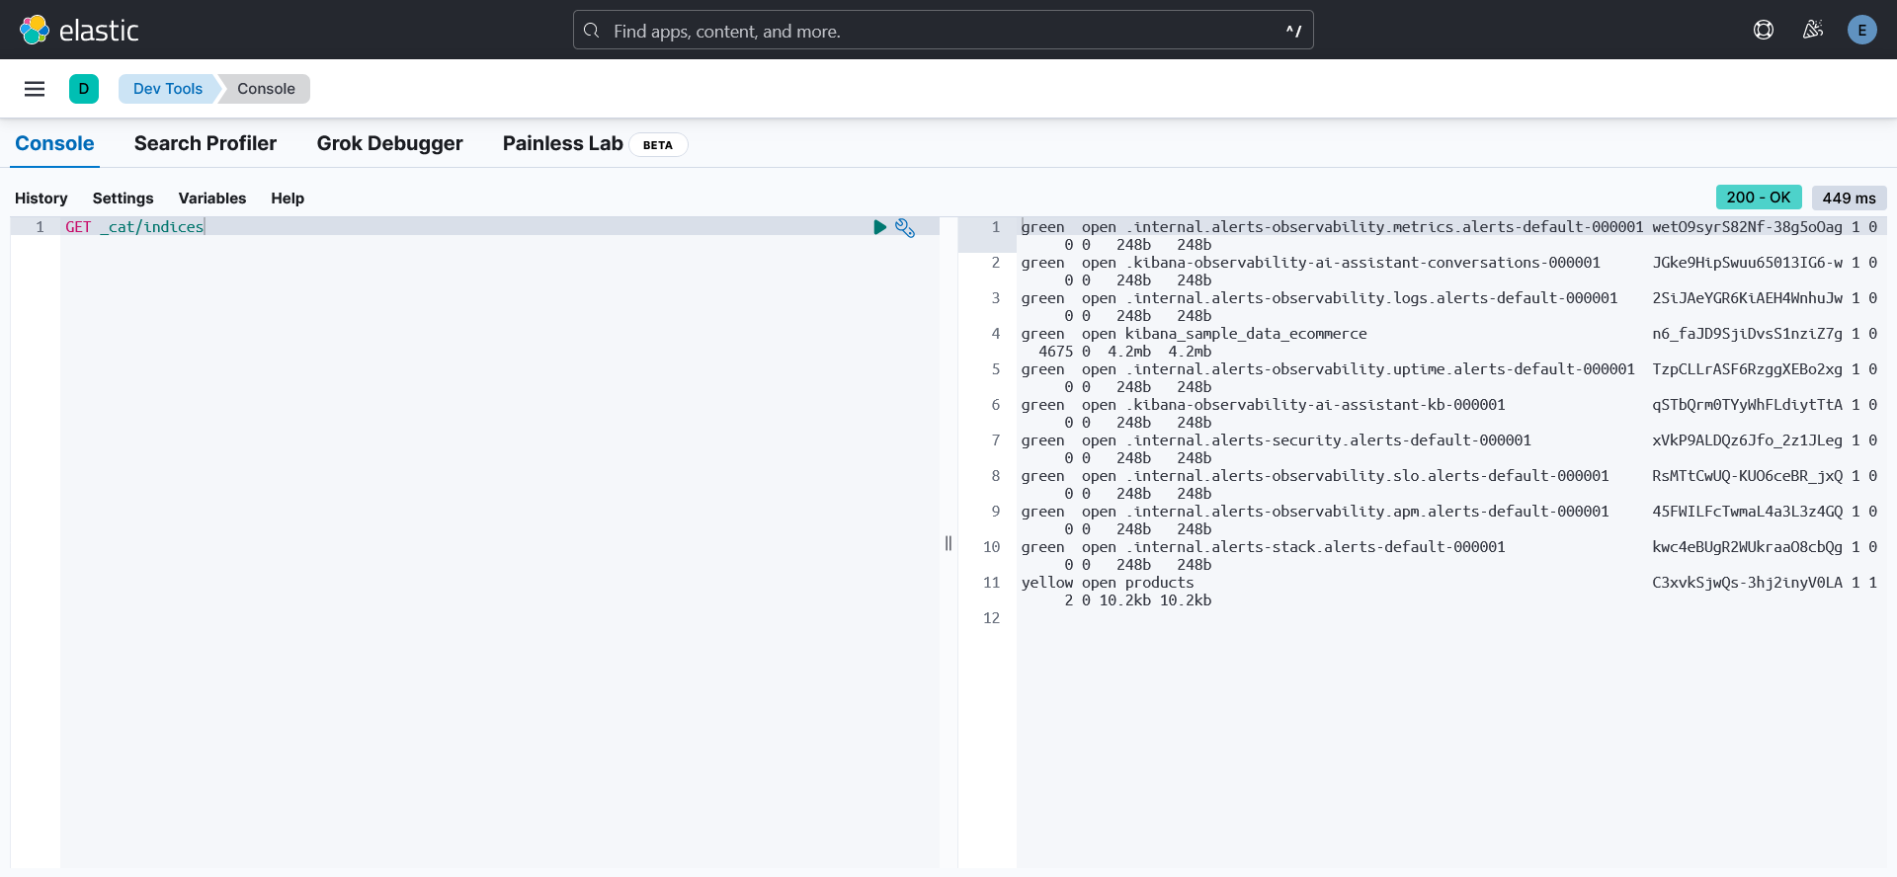

1. "match all" :

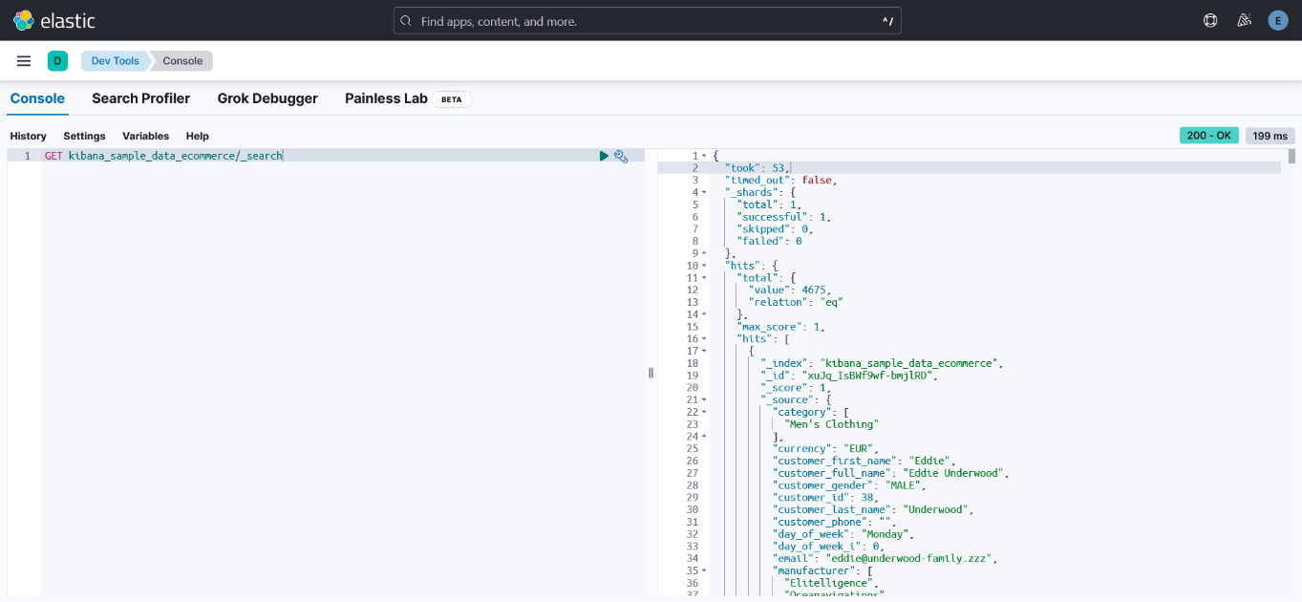

1. _source of 10 documents:

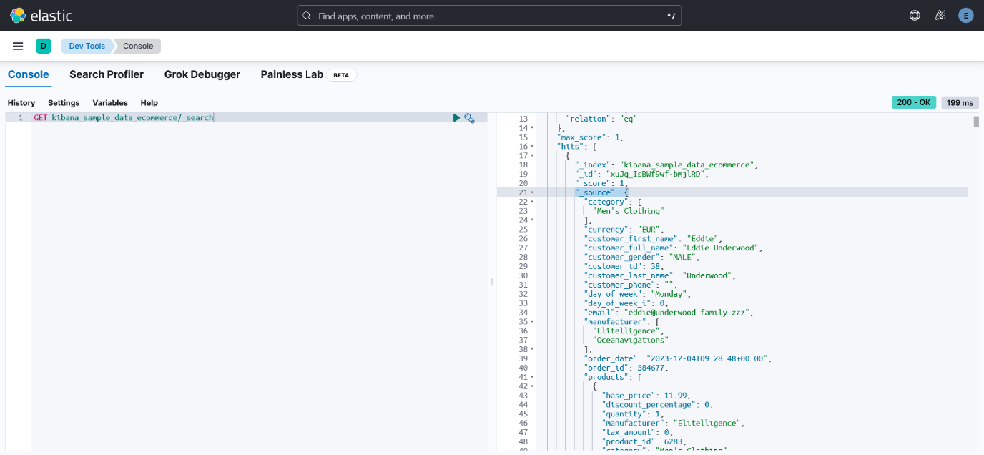

1. .
2. Men's Clothing category

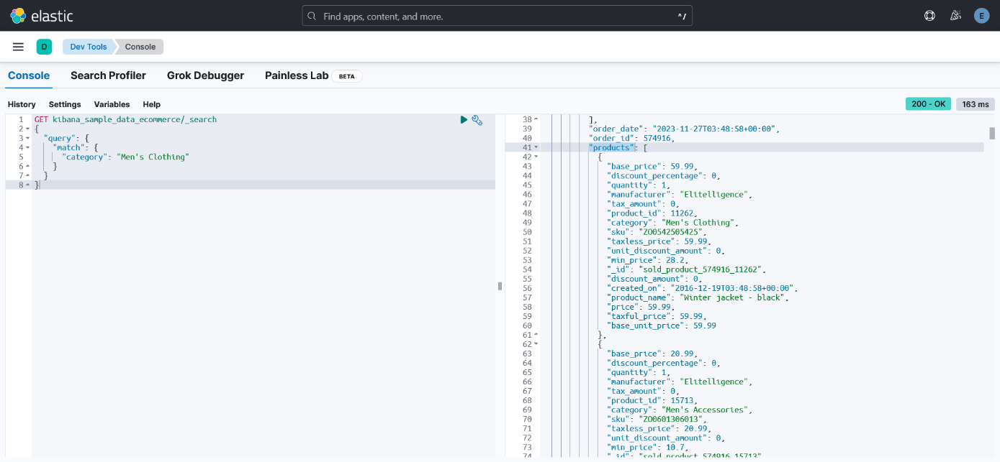

1. 4213 doc matched

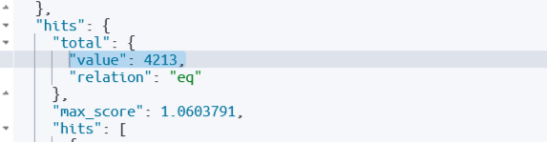

"Men's" or "Clothing” in the category

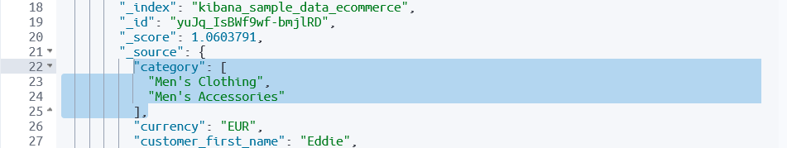

1. improving the previous query

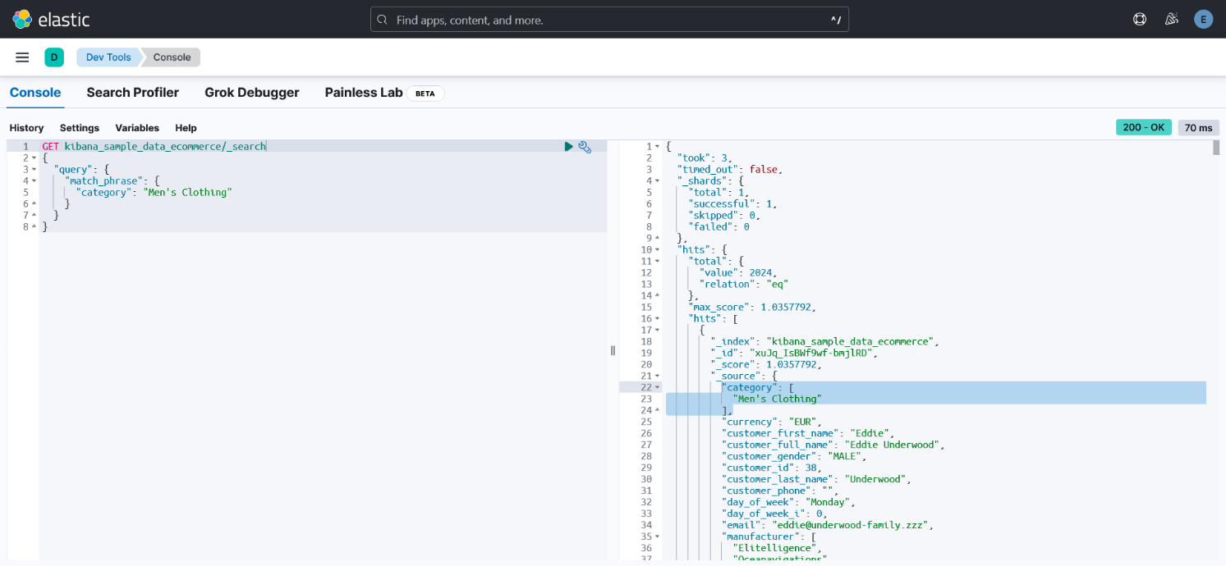

1. 2024 result

